
Northside Elementary School
2223 Cartersville Hwy.
Dallas, GA 30132
770-443-7008

Northside Elementary School families,
If needed, these resources are available for your use. Scan the QR Codes or use the website links to access these helpful resources.
Computer Basics  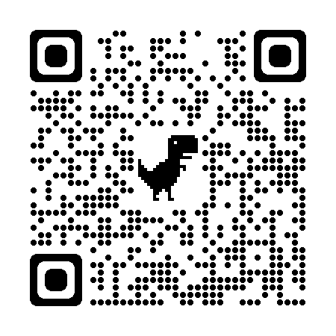  https://tinyurl.com/237zurdk | Copyright Piracy  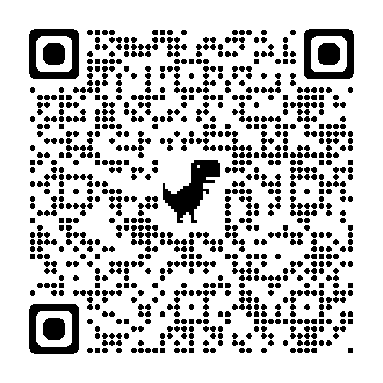  https://tinyurl.com/5838sznn | K-5 Family Tips:  Online Safety & Privacy  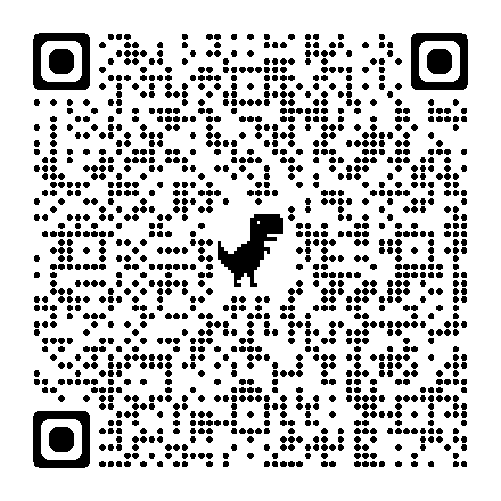  https://tinyurl.com/2p8js5wu
GED Classes  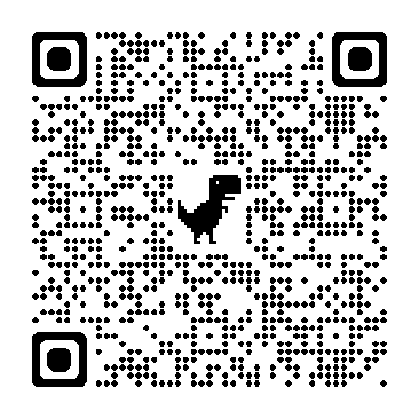  https://tinyurl.com/2hvjkuuh | English as a Second Language Classes  (English and Espanol Flyer)  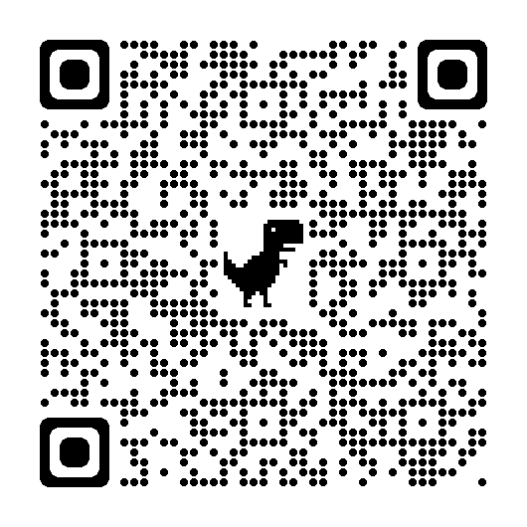  https://tinyurl.com/4pvc4w7n
Please visit our Parent Resource Center located in the front lobby of the school. Parents can check out items to use with their student at home.
If you have any questions about these resources please contact Jill Brogdon, Northside ILT, at (770) 443-7008 ext. 18010 or jbrogdon@paulding.k12.ga.us.

